
ALL INDIA STATE BANK OFFICERS’ FEDERATION
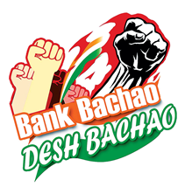
(Registered under the Trade Unions Act 1926, Registration No: 727/MDS)
Central Office: State Bank Buildings, St. Mark’s Road, Bangalore-560 001
Registered Office: 22, Rajaji Salai, Chennai- 600 001

CIRCULAR NO. 64 DATE: 19.10.2022
TO ALL AFFILIATES

Dear Comrades,
State Bank of India Officer’s Association (Kerala Circle)
8th Triennial General Council Meeting 16.10.2022
A stupendous display of solidarity

All roads led to AKG Hall, Thiruvananthapuram rechristened as Com Ramanathan Nagar on 16th October 2022, and the venue of the 8th Triennial General Council meeting of our affiliate SBIOA (Kerala Circle). A massive congregation of officers, well-wishers, veterans, and a fraternity of trade unions descended on the venue. This is yet another stupendous display of the legacy, militancy, and passion of trade union activities for which the comrades of our Kerala state are known.
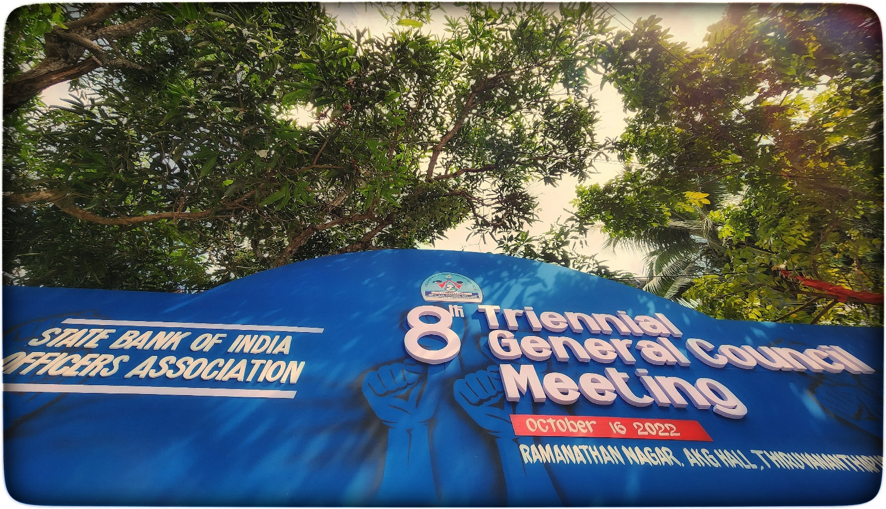
2. The General Council meeting commenced with the hoisting of the flag of SBIOA by the President and General Secretary of SBIOA (Kerala Circle) in the august presence of the President, AISBOF and the undersigned and in the presence of the Presidents and General Secretaries of other affiliates of AISBOF. The venue reverberated with thunderous slogans, raising the passion for trade unionism in each member present on the occasion. Over 2500 delegates attended the General Council Meeting. More endearing to us was the significant presence of women and youth, infusing the conference with vigour and vitality. This was the biggest conglomeration of bank officers in Thiruvananthapuram and SBIOA Kerala could proudly showcase the strength, unity, and commitment of the officers' fraternity to the entire country.
3. The Presidents and General Secretaries of other circles coming from every nook and corner of the country were welcomed on the dais with slogans and rousing reception by the President and General Secretary and office bearers of the host Circle.
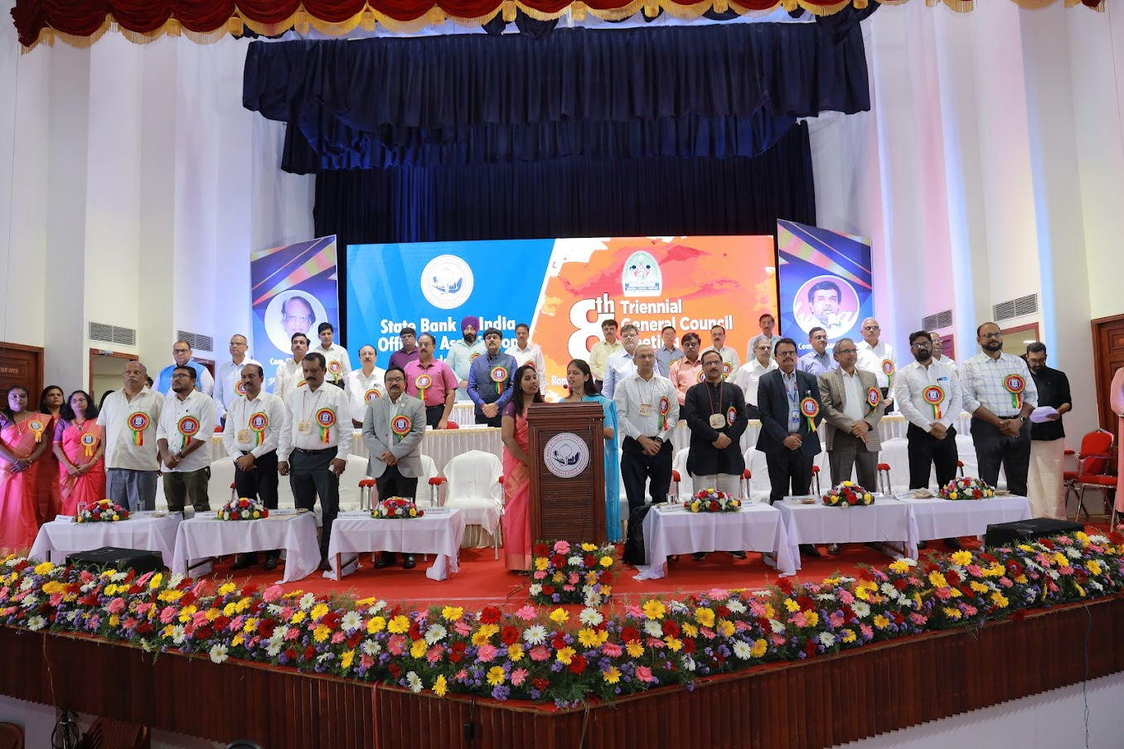
Com.Deepak Kumar Sharma | President | AISBOF
Com.Nilesh Radia  Com.Pinakin Brahm Bhatt | President  General Secretary | Ahmedabad
Com.Kiran Mathada | General Secretary | Bangalore
Com.Nalla Perumal Pillai P  Com.R.Balaji | President  General Secretary | Chennai
Com. Jatinder Pal Singh Sethi  Com.Sushil Ahuja | President  General Secretary | Delhi
Com.S. Appa Swamy  Com. A. Sai Prasad | President  General Secretary | Hyderabad
Com.Vinay Kumar Bhalla | General Secretary | Jaipur
Com.Madan Kishore Jain | President | Bhopal
Com.A.K.Agnihotri | President | Lucknow
Com.Mohan Shamji Gohil  Com.Manohar Baboo Devrukhkar | President  General Secretary | Mumbai Metro
Com.Udaram Hedaoo  Com.Bhushan Mahajan | President  General Secretary | Maharashtra
Com.Kamlakar Singh | President | Patna
Com.G. Kishore Kumar | President | Amravati
Com.T.A.P Paul | President | North Eastern
Com.Narendra V Kulkarni | Treasurer | AISBOF

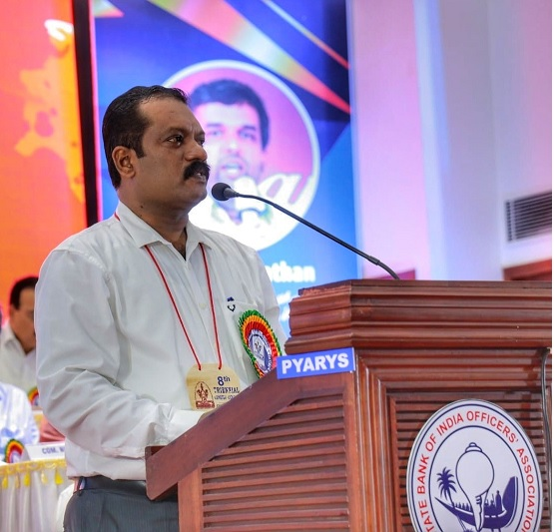
4. The General Council was inaugurated by lighting the lamp by the Honourable Minister of the State for Finance Com. K. N. Balagopal along with the leaders present on the dais which included the President and General Secretary of SBIOA (KC), Com Deepak Kumar Sharma, President, AISBOF Shri Venkata Ramana Bayireddy, CGM and the General Managers of the Circle, leaders from fraternal associations and Presidents and General Secretaries of SBIOA from our affiliates from various Circles and the undersigned. Com Rajesh S, General Secretary, SBIOA Kerala Circle, welcomed the gathering. He touched upon the importance of the General Council in the present scenario in the backdrop of privatisation and the challenges ahead. He urged upon the members and the bank to devise suitable strategies to get adapted to the changing environment. He expressed that unity amongst membership and solidarity of the members was the need of the hour.
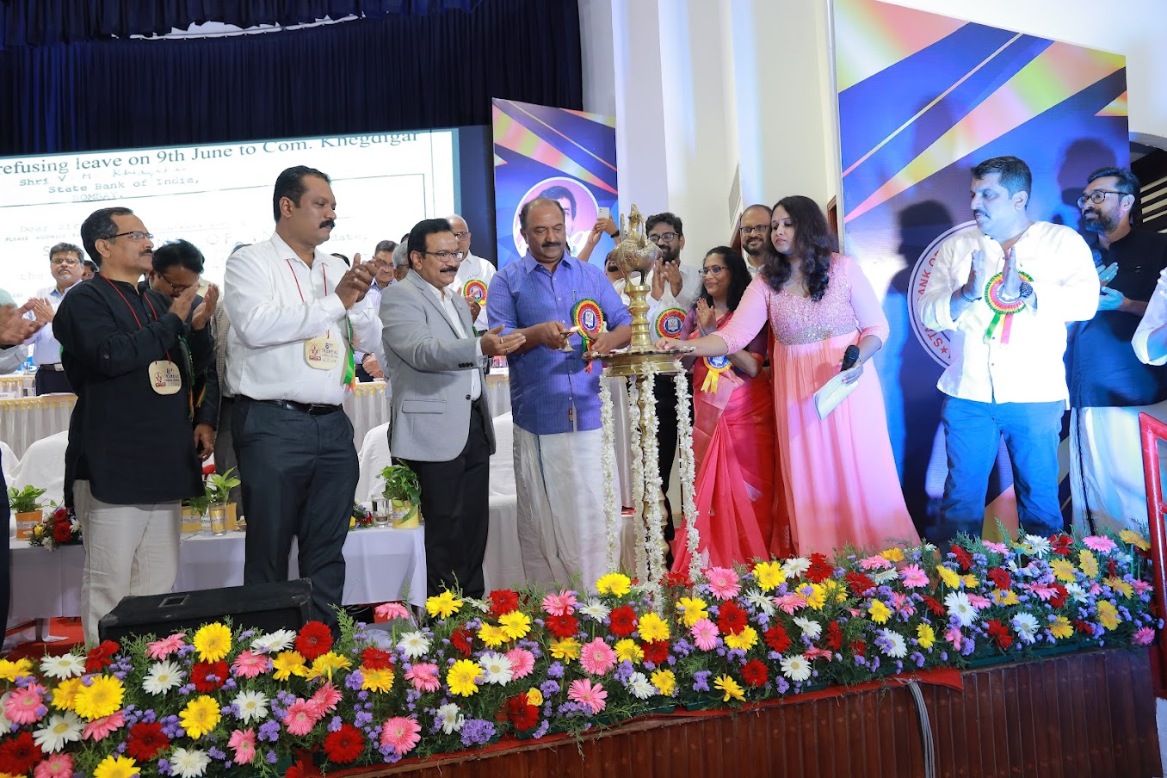
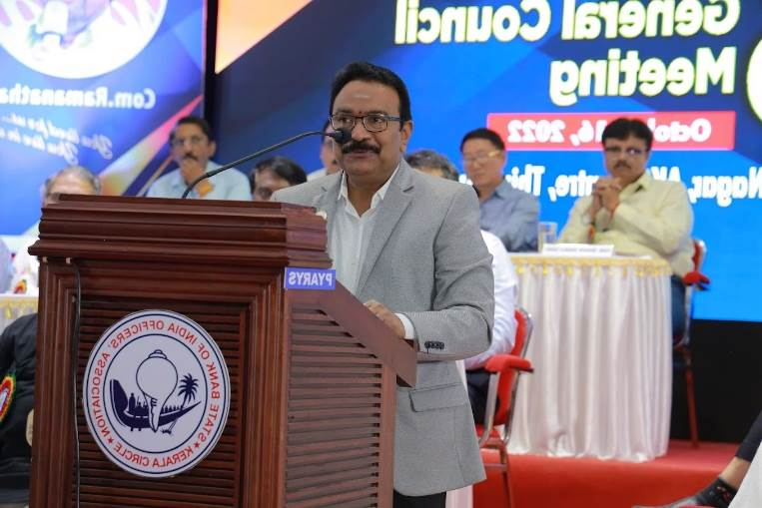
5. Shri Venkata Ramana Bayireddy CGM, Thiruvananthapuram Circle expressed his pleasure in meeting the SBI family and Association leadership. He expressed that the circle has an abundance of vibrant and talented officers and both Association and the management should work together to achieve our goals and take the Bank to greater heights. The Circle staff is well-equipped with job knowledge and logical thinking, he said. The staff is providing good customer service. He expressed his deep appreciation to the officer community. However, he also urged upon the members present to strive harder to improve the CD ratio of the state, which was hovering around 51%, way below the all-India average of about 71%.
6. Shri K.N. Balagopal, Hon’ble Minister of Finance, Govt. of Kerala and Chief Guest of the function appreciated SBI for its important role in Kerala as a bigger bank after the merger. He urged upon the need for good customer service in rural areas. He also expressed his concern such as the delay in sanctioning business loans and advised to have a separate virtual platform for easy approval of SME and Education loans. He advised to give more thrust in recovering loans availed by the big business community. He expressed his appreciation towards Public Sector Banks for providing good services and implementing social security schemes of the Government.
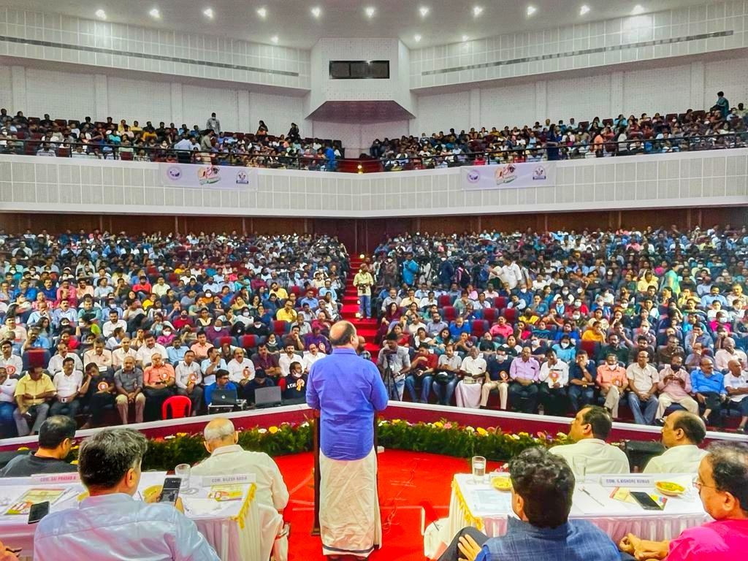
7. Former leaders of the circle were felicitated as a recognition of their contribution in:
Com. M.Sreenath | Former President AISBOF and GS Kerala Circle
Com. P V Sivashankara Pillai | Former General Secretary Associate Bank Officers Association and ABOA unit SBT
Com. Chandrasenan | Former president ABOA SBT
Com. Vinayachandran S | Former President SBOIA KC
Com. R.Sreeraj | Former General Secretary ABOA SBT
Com. Janardhanan P | Former President SBIOA KC
Com. N.Jayakrishnan | Former President ABOA SBT
Com. V.Harinarayanan | Former President ABOA SBT
Com. V.Muraleedharan | Former GS SBIOA KC
Com. C.P.Krishnanandan | Former President SBOIA KC
Com. G.R.Jayakrishnan | Former General Secretary SBOIA KC
Com. V.K.Premachandran | Former President SBIOA KC

Shri A. Satheesh Kumar, an eminent Cartoonist and member of the Election team was also felicitated.
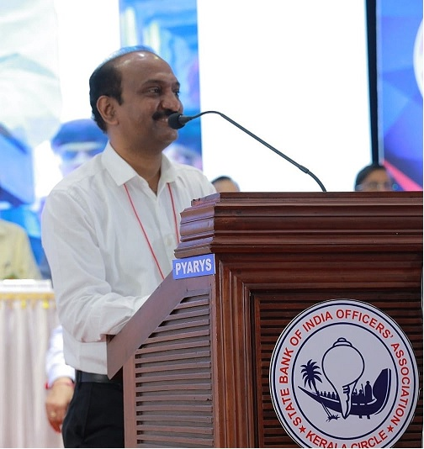
8. Com. Biju T President of SBIOA (KC) in his presidential address welcomed all the affiliate leaders and AISBOF leadership. He expressed that the presence of over 2500 members and show of camaraderie has made the 8th triennial a historic one and infused additional strength to all newly elected office bearers to work effectively and in unison to espouse the cause of the members. He worried that the digital transformation of transactions had given a fillip to the entry of more Fintech Companies into the Banking foray having large-scale security threats. The pressure of the present ruling dispensation into the banking arena has created an additional workload for officers in the implementation of various schemes throughout the year. He also expressed his concern about work-life balance and the shortage of manpower. He urged all officers particularly youngsters to take part in all organizational activities and strengthen the Association.
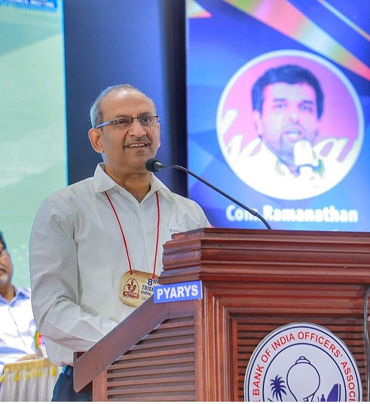
9. The undersigned before delivering his keynote address, felicitated the newly elected president and General Secretary of SBIOA (Kerala Circle) Com. Rajesh S and Com. Biju T, respectively along with Com Deepak K Sharma, President, AISBOF. In his address, he expressed happiness in witnessing the exuberance of youth amongst the participants. He congratulated the members, who had assembled from the far-flung districts of Kasaragod, Kannur, Wayanad, Kozhikode and from every nook and corner of the state to take part in the historic 8th Triennial General Council meeting in a spectacular show of solidarity. He reminisced about his earlier years in the Executive Committee of the Federation, where he had the opportunity of working with former leaders including e-associate office bearers, who were felicitated in the meeting and also his emotional attachment with the Circle. He appreciated the role of SBIOA (Kerala Circle) in organizing a state-wide strike under the banner of AIBOC in support of the CSB Officers’ Association. He narrated the role of the Federation in resolving several issues of Kerala circle including payment of demonetization compensation to all officers in 2021, which was a landmark achievement considering the fact that all circles had paid compensation in 2017. He opined that the “Power of unity” will always be a befitting counter to the “Arrogance of Power” and harped on the need to be united. He elaborated on many issues such as the introduction of a 5-day work week, which was being actively considered by IBA and DFS. He stressed the need to ensure that human dignity is respected in the workplace. He urged upon members not to vent out personal grievances on social media, which is inimical to the image of the bank and also to counter any negative pots which sullied the image of our esteemed institution. He appealed to all the participants to like the Facebook page www.facebook.com/BankBachaoDeshBachao/ and encourage all stakeholders to join the battle against privatisation. While speaking on bank-level issues, he mentioned upon issues like wage disparity, work-life balance etc.
Com Biju T, President, along with Com Rajesh S, accompanied by Com VK Premachandran and G R Jayakrishnan former President and General Secretary of SBIOA (Kerala Circle) felicitated the undersigned in the backdrop of his ensuing superannuation on 30th November 2022 by presenting a memento, a very special artwork of Kerala State depicting a Kathakali dancer.
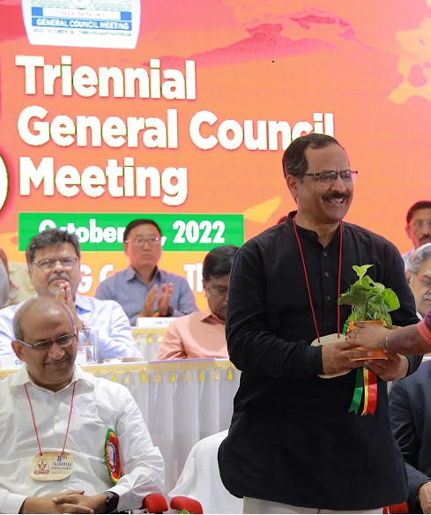
10. Com. Deepak Kumar Sharma, President AISBOF congratulated team Kerala for organizing a successful and grand General Council meeting. In his address to the gathering, he touched upon many issues such as the unilateral decision of the management, discrimination and injustice. “Our image is being tarnished in a systematic manner by ignoring our contribution to the country’s economy”, he said. Non-appointment of an officer or workmen director on the board of the Bank is pending for a long. Big sharks are ready to take away all our resources and try to convert us to another BSNL or Air India. All these moves are to be resisted strongly and unitedly with 100% support to Association, Federation, and Confederation. He advised the members to sacrifice their comforts and personal interest for the cause of peaceful revolution for our own future. He urged upon the members to implement each call given by Association, Federation and Confederation in letter and spirit. He also called upon the members to participate in demonstrations, social media campaigns, agitational programs, strike calls etc. in large numbers. He congratulated the Confederation leadership for the successful and historic wage settlement with the introduction of a new feature PLI which is an indirect bonus to all, and other achievements like encashment of 5/7 days leave, learning allowance, location allowance for non-CCA centers, the introduction of additional stagnation increments from Scale 1 to 4and one stagnation increment to Scale -5 officers for the first time etc.
He touched upon the working environment at the operation level and staff shortage, connectivity problems etc. One of the major concerns is an unhealthy strategy adopted by some of the controllers in achieving targets resulting in quick mortality and loss to the bank. He too, urged upon members to work sincerely to make our esteemed organisation scale new heights. He concluded the speech with vibrant slogans that were responded to enthusiastically by the entire house.
Com Akhil S., President of SBSU(KC) and Com Jayakumar, General Secretary, SBIPA (KC) also addressed the gathering and congratulated SBIOA (Kerala Circle) for the grand show of solidarity.
The Opening session was concluded with a vote of thanks proposed by Com. V. Jagannathan, Convenor Reception Committee and DGS Thiruvananthapuram.
11. In the delegate session, the General Secretary presented the report after which deliberations were made by 20 members, who gave suggestions and made constructive criticisms on matters including delay in effecting transfers, salary fixation, issues at single officer branches, non-payment of allowances, infrastructure improvement in Airport counters, IR issues arising out of an attitude of some controllers, work pressure, inordinate pressure for selling JV products, issues related to NPS, conversion of RMROs as General cadre officers, Ex-servicemen officers’ salary fitment issues, lack of effective training programs and detailed and excessive compliance structure in our bank, OTMS issues etc. The General Secretary gave suitable replies to all the queries and suggestions made by the delegates.
Com. Mahesh Jayan O M, Asst Secretary (Finance) extended a vote of thanks to the delegate session.
The General Council came to a close at 6:00 pm with the lowering of the flag, bringing down the curtain on the historic event.
12. We congratulate our affiliate, SBIOA (Kerala Circle), and the vibrant comrades who made the General Council an outstanding success and an occasion to remember.
With greetings,
Yours Comradely

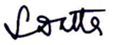
(Soumya Datta)
General Secretary

At the Service of Members for more than 5 Decades
General Secretary: 9830044737, Kolkata-033-22130154, Fax: 033-22101684
Bengaluru: (Dir) 080 2221 1006 General: 25943132 Fax: 2221 4959
Email: aisbofbangalore@gmail.com Web: www.aisbof.org

