BIO-DATA
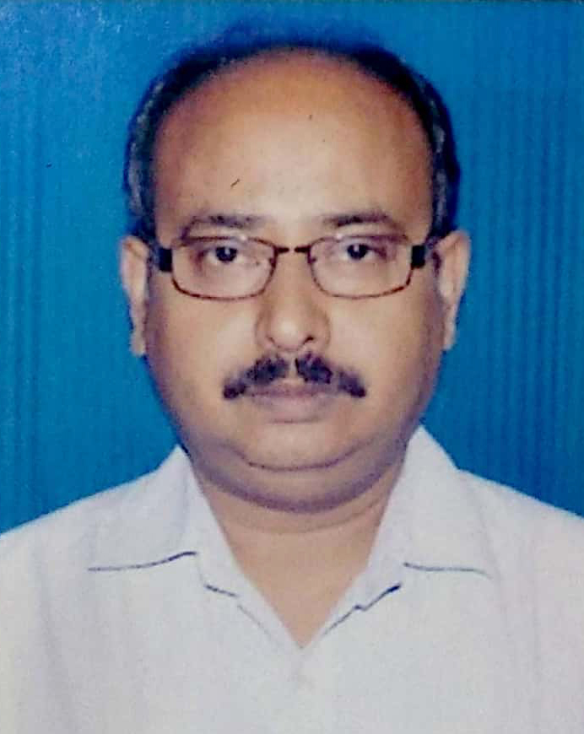

(a) Name : PRABIR SORKHEL

(b) Date of Joining : 20.06.1994

(c) Branch : Local Head Office, Kolkata

(d) Present Grade : MMGS-II

(e) Office Address : STATE BANK OF INDIA, LHO, SAMRIDDHI
(With Pin Code Number) BHAVAN, GBU DEPT., 7TH FLOOR, ‘B’ BLOCK,
1, STRAND ROAD, KOLKATA – 700001.

(f) Residential Address : No. 2, SankhariPukur,
PO – Sripally, PS –Burdwan,
Pin : 713103

(g) Telephone Numbers : Mobile : +918001195920 / +919434153600

Fax No. : (033) 2210 1684

(h) E-Mail address : prabirsorkhel@gmail.com

(i) Date of Birth & Place : 16.01.1969, Burdwan, West Bengal

(j) Qualifications : B.Sc(Physics)

(k) Extra-Curricular activities : Drama
while at school / college
Sports : Nil
Histrionic : Acting in Drama, Singing

Social :
(l) Leadership in
School/College Union : Secretary, President of SFI, College Unit, Member, Dist. Committee, SFI, General Secretary, College Union, Cultural Secretary, University Students Union

(m) Employment prior to : Nil
Joining the bank

(n) Organisation : N / A

(o) Career Information in the Bank :
i) Joined as : Clerk cum Cashier
ii) Promoted to : JMGS - I (12.08.2008)
iii) Promoted to : MMGS-II (30.09.2014)
iv) Promoted to :
v) Promoted to :

(p) Positions held in the Bank : Bank
Post held : From – To

i)Clerical 1994-July, 2008
ii)Field Officer at
Harishchandrapur Sept. 2008- Sept.2009
iii) Service Manager
Mangalbari Oct. 2009- Sept. 2010
iv) Desk Officer (HR)
RBO, Malda Oct. 2010- Mar. 2012
v) Desk Officer (Govt.)
Burdwan Apr. 2012-Aug.2016
vi) Branch Manager
Boga Sept. 2016-Dec.2016
vii)Desk Officer, GBU
LHO, Kolkata Jan.2017- till Date

(q) Association activities :
(briefly state the office held
And name of organization)
- Workmen Organisation : Post held : From – To
Name of the Union Unit Secretary, SBI
SBI Staff Association Workmen Union (Bhopal Circle) 1995 -1999
Unit Secretary, Bishnupur 2002 - 2004 SBISA (Bengal Circle)
Unit Secretary, Sonamukhi 2006 - 2008 SBISA (Bengal Circle)

- Officers’ Organisation : Post held : From – To
Name of the Organisation President, Malda Comp. Unit 2010-Mar,2012
SBIOA (Bengal Circle)
Regional Secretary, Region- I, May,12-Aug,16
AZC, Burdwan, SBIOA (Bengal Circle)
Central Committee Member Dec,16-till date
SBIOA (Bengal Circle)
Asstt. Secretary Jan.18-till date
SBIOA (Bengal Circle)
(r) Present Office held in

- Association : Asstt. Secretary SBIOA (Bengal Circle)
- Federation :
- Confederation
State Level : Vice-President, WBSU
Central Level : Admin Secretary National AIBOC

(s) Personal Data
(1) Marital status : Married
(2) Whether spouse
Employed: if so, details
Regarding employment : No
(3) Children : one daughter
Education : studying in class - X
Occupation :

(f) Any other relevant information :

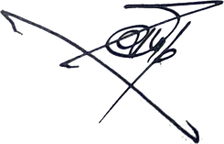

Place : Kolkata __________________________________________
Date : 08.11.2019 (SIGNATURE)

